APP

# AIM

TO CREATE A APP AS A GROUP

# PROCEDURE

CREATE A GROUP

CREATE A BASIC IDEA OF THE APP OR WEBSITE

SELECT THE NUMBER OF FRAMES

DESIGN THE APP

DO THE PROTOTYPING

EXECUTE THE APP OR WEBSITE

# IMAGE

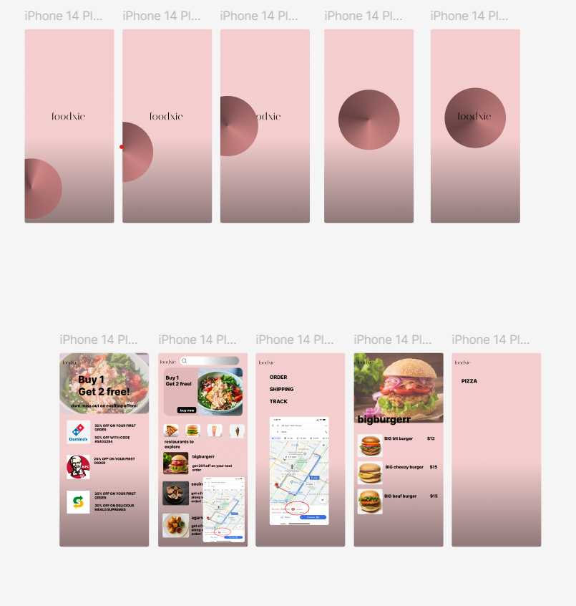

# RESULT

APP IS DESIGNED